PATIENT INFORMATION

PATIENT NAME: ____________________________________________ _____________________ __________________ __________
LAST FIRST MIDDLE INITIAL

MAILING ADDRESS: _______________________________________________________________ CITY:______________________ ST __________________ ZIP___________________

PHYSICAL ADDRESS:__________________________________________________________________CITY: _____________________ ST: ________________ ZIP: __________________

HOME PHONE #: ______________ ( ) CELL#: _________________( ) WORK PHONE #: _____________( ) check preferred

DOB : _____/______/_______ SOCIAL SECURITY NUMBER: _______-______-________ DRIVERS LIENCE #____________________________________

SEX: FEMALE MALE (circle one) MARITAL STATUS: (circle one) SINGLE MARRIED DIVORCED WIDOWED OTHER

IF MINOR NAME OF GUARADIAN:_____________________________________________ PHONE# __________________________________________________

PATIENTS EMPLOYER INFORMATION:

COMPANY: __________________________ CITY: ________________________________ PHONE#___________________________________
ACCIDENT INFO: please complete if this visit is due to an accident.
DATE OF ACCIDENT: ________________________ WORK RELATED?____ AUTO ? _______ OTHER?____
If worker’s Comp, please furnish W/C ins info as primary insurance below and enter commercial ins as secondary.

GUARANTOR’S INFORMATION-complete if different than patient

RESP. PARTY NAME: _________________________________________ ___________________________________________ _________________
LAST FIRST MIDDLE INITIAL

ADDRESS: _________________________________________________________________ CITY: ________________________________ ST: ___________________ ZIP:_________________

SEX: (circle one) FEMALE MALE DOB: ________/__________/____________

SOCIAL SECURITY NUMBER: ________-_______-________

HOME PHONE: ________________ ( ) CELL #: ________________( ) WORK #: ________________( )check preferred

RESPONSIBLE PARTY'S EMPLOYER INFORMATION:
COMPANY: ___________________________ CITY: _________________________ PHONE #: ___________________________

INSURANCE INFORMATION
PRIMARY INSURANCE COMPANY: ______________________________________________ PHONE#_______________________________________

POLICY NUMBER: ____________________ GROUP NUMBER: ___________________________

SUBSCRIBER’S NAME: _______________________ SUBSCRIBER’S DOB _________________ SOCIAL SECURITY: _________________________________________

PATIENT RELATIONSHIP TO SUBSCRIBER: (circle one) SELF SPOUSE CHILD OTHER

SECONDARY INSURANCE COMPANY: ____________________________________________ PHONE#_______________________________________

POLICY NUMBER: ____________________ GROUP NUMBER: ___________________________

SUBSCRIBER’S NAME: _______________________ SUBSCRIBER’S DOB _________________ SOCIAL SECURITY: _________________________________________

PATIENT RELATIONSHIP TO SUBSCRIBER: (circle one) SELF SPOUSE CHILD OTHER

MEDICATIONS

Medication | Dose | Times Taken | Reason for Medication

ALLERGIES AND SENSITIVITIES

Name of Item | Reaction (s)

Are you currently taking any blood thinners? Yes No

Are you currently taking any narcotic pain medicine? Yes No

Are you currently on a pain contract with another provider? Yes No If yes, who with?__________

Name: ________________________________________ Date: ____________________________

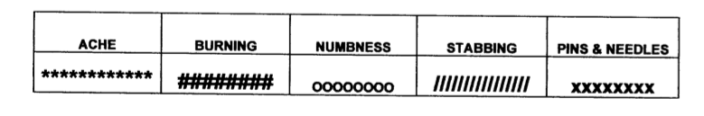
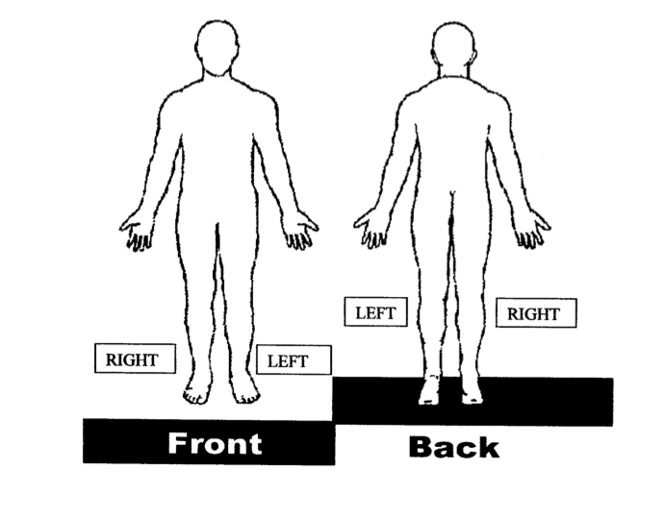
Date of Birth: __________________________________ Age: _____________________________

Mark the areas on the body below where you feel the described sensations. Use the appropriate symbol and include all affected areas.

Name:___________________ Date:____________  Age:_____ Hand Dominance: _____ DOB:______  Chief Complaint  __Low back pain __ with radiation to legs __ without radiation to legs.  __ Neck pain __ with radiation to arms  __ without radiation to arms  Pain Scale: (1 to 10- 10 being worst pain)  Worst:___ Best:___ Current:___  Aggravated by: (check all that apply)  __sitting __lying __driving __bending __walking __twisting __standing __coughing/sneezing __pushing/pulling __flex/ extending  __other: __________________________  Best time of the day:_________ am / pm  Worst time of the day:________ am / pm  Alleviated by: ______________________  Treatment  Chiropractic Care TENS UNIT  Brace Other MD work-up  Past Spine Surgeries _______________________  __ Physical Therapy __ Injections  _________________________________________ Past Medical History  __ Diabetic __ High Blood Pressure  __ Heart disease __ Stroke  __ Irregular Heart beat __ Hepatitis  __ Heart Attack __ Alcoholism  __ Drug Addiction __ Bipolar disorder  __ Kidney/Bladder __ Seizures  __DVT __ Pacemaker  __ Asthma __ HIV/AIDS  Other:____________________________________  Past Surgical History | Referring Doctor:_______________________  Primary Care Doctor: ___________________  Cardiologist ___________________________  Social History  __ single __married __ divorced __ widowed  # of children ___ Ages  Hobbies: _______________________________  Nicotine use: __Yes ___NO  amount per day ____ # Years _____  Alcohol Consumption: ____ Yes ____ No  # per day _____ # Years _____  Work History  Employer: ______________________________  Job Title: _______________________________  Length of Employment: ___ years _____ months  Last worked: _____ Do you enjoy work: _______ Modified work available:___ WC Litigation _____  Disability Insurance: _______ SSI: ___________  Education: ____________________________  Family History  Mother’s age(or age at death)  Alive Yes No  Mother’s Medical Problems: ______________  Father’s age(or age at death)  Alive Yes No  Father’s Medical Problems: ______________

REVIEW OF SYSTEMS:  Please Mark All That Apply To You:  Constitutional  Altered taste/smell ____Depression  ____Cancer ____Anxiety  ____Change in appetite ____Recent sore throat  ____Excessive sleeping ____Sleep Apnea  ____Fatigue ____Weight loss or gain  ____Fever  Hemilymphatic/Endocrine  Anemia ____Lymph node swelling  Blood disorder ____Hepatitis  ____Circulatory problem ____HIV/AIDS  ____Diabetes ____Pituitary disorder  ____Dry eyes/mouth ____Sickle cell disease  ____Endocrine disorder ____Thyroid disease  ____Low blood sugar  Ears/Nose/Throat  Hearing loss Sinus disease  Trouble swallowing Ringing in ears  Mouth sores  Eyes  Blurred Vision ___Peripheral vision issues  Cataracts ___Visual impairment  Double vision Glaucoma  Macular degeneration  Cardiovascular  Chest pain/pressure ___Leg Swelling  Fainting Low blood pressure  Heart Attack High blood pressure  Heart defect Heart murmur  Musculoskeletal  ___ Connective tissue disorder ___ Joint Swelling  ___ Low back pain  ___Neck pain  ___Joint pain | Gastrointestinal  Black stool ____Ulcer  Constipation ____Vomiting  Diarrhea  Gall bladder problems  Genitourinary  Blood in urine ____Loss of control  Change in habits ____Painful urination  Infection in urine ____Urinary urgency  Kidney disease ____Vaginal bleeding  Kidney stones  Neurological  Balance Difficulty ____Nausea  Choking ____Numbness  Clumsiness ____Personality change  Confusion ____Seizure  Concentration difficulty ____Shooting pain  Dizziness ____Smelling difficulty  Drooling ____Stroke  Falls ____Tasting difficulty  Hallucinations ____Tingling sensation  Headaches ____Vertigo  Loss of consciousness ____Walking difficulty  Memory problems  Muscle twitching  ________________________________________________  Skin  Birth mark ____Melanoma  Psoriasis  Skin rashes  ________________________________________________  Respiratory  ____ Asthma ____Trouble breathing  ____Bronchitis ____Tuberculosis  ____Chronic cough ____Wheezing  ____COPD ____Pneumonia  ____Emphysema ____Shortness of Breath

Blue Cross Blue Shield-Payment Affidavit

We are NOT a participating provider with BCBS/FEP. We will assist you in applying for an out-of-network exceptions with your insurance. In some cases, your insurance policy may require you to request the out of network exception yourself. You will be responsible for COPAYS, DEDUCTIBLES, AND COINSURANCE.

Because we are a non-participating provider BCBS/FEP they may mail payment directly to you instead of to our office for your service.

By signing this affidavit, you are agreeing to immediately sign over any and all checks from BCBS/FEP for services related to Spine Care Specialist of Alaska, LLC. Failure to do sign will result in legal action.

I, _________________________________________, promise to turn over all Federal Blue Cross Insurance checks to Spine Care Specialists of Alaska immediately after receiving them. I am responsible for any and all deductibles and/or copays required by Blue Cross. If all checks are not turned over, any remaining balance will be my responsibility and will be due in full within 30 days.

____________________________________________ Signature ______________ Date

SPINE CARE SPECIALISTS OF ALASKA,LLC
Financial Policy

- Welcome to Spine care Specialists of Alaska. We are please your have chosen us as your care provider. One important aspect of optimal patient care is to have an agreement as to financial responsibility to avoid any misunderstanding and to ensure timely payment for services.
- Patents or their legal representative are ultimately responsible for all charges for services rendered. It is your responsibility to:

- 1. Bring your insurance card/worker’s compensation information to every visit.

- 2. Be prepared to pay your co-pay or deductible at each visit.

- 3. Spine Care Specialists of Alaska is a preferred provider and “in-network” for Aetna. Our office is happy to file claims for all other out of network insurance companies

4. If the patient is a minor (18 years or younger), the parent or guardian must sign below. The parent or guardian is responsible for any payment due.

5. If you have any questions about your insurance, we are happy to help you. Specific coverage issues, however, should be directed to your insurance company member services department (the number is usually on the back of the insurance card).

7. Our practice firmly believes that a good provider/patient relationship is based upon understanding and good communication. Questions about financial arrangements should be directed to the management of office.

Patient’s Name (PLEASE PRINT) ____________________________________________

Patient’s Signature: ________________________________Date__________

SPINE CARE SPECIALISTS OF ALASKA,LLC

HIPAA Acknowledgement

In order to comply with the federal government regulations, Spine Care Specialists of Alaska, LLC are required to have a document available to you that explains our patient privacy information policy. There is a copy of this policy located with the Front Desk Receptionist, if you wish to review.

Please sign and date to acknowledge you have been informed of our policy.

PATIENT’S NAME (print):_________________________________________________

PATIENT’S SIGNATURE: _________________________________DATE:__________

Authorization to release information to the following person(s)

I authorize for Spine Care Specialists of Alaska, LLC to release all medical and financial records, including medication, surgical and appointment details to the following:

Person(s) Name Relationship to Patient Date of Birth__

1._____________________________________________________________________
2.______________________________________________________________________
3.______________________________________________________________________
4.______________________________________________________________________

CONSENT TO USE OR DISCLOSE HEALTH INFORMATION
For Treatment, Payment or Coordination of care with other health care providers

I hereby consent to the use or disclosure of my individuality identifiable health information by Spine Care Specialists of Alaska, LLC in order to carry out treatment, payment or coordination of care with other health care providers.

At all times, I retain the right to revoke this consent. Such revocation must be submitted to Spine Care Specialists of Alaska, LLC in writing. This revocation shall be effective except in those instances that occurred prior to revocation.
By signing below, I have read and understand this information. I am the patient or the individual authorized to act on the behalf of the patient.

Patient Signature: ______________________________Date:______________________

SPINE CARE SPECIALISTS OF ALASKA

Medication Refill Policy

Spine Care Specialists of Alaska, LLC would like to make the medication refill process as easy as possible for all our patients. Spine Care Specialist of Alaska has developed a few guidelines to inform you of the process for requesting new or refills on your medication. Please read below and sign to acknowledge you do understand our policy.

- Please allow 48-72 hours to process your medication refills. Due to our unpredictable surgery schedule, medication refills may not be approved or signed quickly.

- Please make sure you contact our office 7 business days in advance for medication refills. Please be aware we do not fill new prescriptions or refills of any medication on Fridays or over the weekend. If you need a refill, please have your pharmacy fax a refill request to 907-456-3877 and once approved by the provider we will fax it back to the appropriate pharmacy.

- Please give the office advanced notice if your medications are due to run out over a weekend/holiday and/or if you will be out of town. Again, this could take up to 48-72 hours to complete the refill process.

- Please notify us of any drug allergies or side effects- ALLERGIES:__________________________________

- Some medications cannot be phoned-in or faxed to the pharmacy due to narcotics requiring a written prescription from the provider. Once your prescription is ready for pick up at our office will contact you to pick up during the following hours of operation: 9am to 5pm Monday through Friday.

- For your safety, it is important that you take all mediations as prescribed and routinely update your current medications in our records to avoid contraindications with your prescriptions. You may only receive pain mediation from one provider. We cannot replace lost, stolen, destroyed narcotics or any other type of medication. We will not refill medication until that original prescription is due to be filled.

If you use a local pharmacy for all of your prescription needs, please complete the portion below to help us expedite your medication refills:

Pharmacy: ___________________________________ Phone: ___________________Fax:____________________

Pharmacy Location/Address: ______________________________________________________________________

IF YOU HAVE A PAIN MANAGEMENT PROVIDER OR PAIN CONTRACT
PLEASE LIST THE INFORMATION BELOW

Provider’s Name: ________________________________Address:____________________________________
Phone #:_______________________________________Contract Date: ______________________________

By signing below, you have provided Spine Care Specialists of Alaska, LLC correct information and have read and clearly understand the instructions listed above.
______________________________________________________________________________________

